Statement of Intent
Facilities and Services Fund for Sustainability Projects
Please consult the Sustainability Office website for details about the application process and detailed project criteria: http://sustainability.utoronto.ca/projects/fund.htm

A | Project Information
 | Building(s): GreenLab, BlueRoof, and TeachBeach to be constructed on the roof of Wallberg Building or any other suitable space on the roof of a U of T building | Room Number(s): Roof of Wallberg building or roof space above EA302 and 304, or any other suitable space on a flat rooftop  (if applicable)
 | Primary Contact Person:  Principal investigator: Prof. Steve Mann  (E.C.E. and C.S.)  Secondary Contact Persons:  Co-investigators: Prof. Elizabeth Edwards  (Chem. Eng.); Prof. Tim Bender (Chem. Eng.);  Prof. Philip H. Byer (Civ. Eng.) | Phone #:  416.946-3387 (office);  416.946-5321 (lab);  416.593-9330 (home).  Email address: mann@eecg.toronto.edu or hydraulophone@gmail.com
Project Description:

Executive Summary
The GreenLab is a proposed solar powered rooftop space that would be part teaching space, part green-tech research lab (“GreenLab”), and part patio space that will give students and faculty a comfortable outdoor place to work and meet. The GreenLab would produce/save energy through the incorporation of a photo-voltaic (PV) array that will provide electricity to be exported to the grid under the new Feed In Tariff (FIT) subsidy, which would shade a significant portion of the existing rooftop thereby causing a reduction in the building cooling load. However, the GreenLab would provide more than just energy production and savings; it would expand the amount of usable space and provide an unprecedented learning environment where students could save energy while learning about the process of saving energy. It would also serve as a visible and accessible collaborative space for a wide variety of sustainability efforts by professors, students, and University of Toronto research groups to mount and test green-tech innovations. In addition, the design and construction of the project would be a collaborative process involving students in the design processes as much as possible.
Concept:

The GreenLab would involve the creation of a green, self-sustained, teaching and research lab, a portion of which would be an outdoor lab, for sustainability courses such as courses in the Faculty of Applied Science and Engineering and any other courses or research that may be undertaken or taught in the space.

The GreenLab would include both an outdoor lab as well as a greenhouse environment (retractable in summer) for people. It is well known that people function better in winter if there is adequate sunlight.

Background:

Many existing classrooms or labs are disconnected from the environment. Many of them have windows that do not open, and some even don't have windows at all! Seasonal Affective Disorder (SAD), also known as winter depression or winter blues, is a mood disorder in which people who have normal mental health throughout most of the year experience depressive symptoms in the winter or, sometimes even in the summer [Wikipedia; NYT August 13, 2002].

The GreenLab would provide more than just money savings. It would provide health and wellbeing for students, staff, and faculty. It would also provide a learning environment where people can save energy while learning about the process of saving energy. Additionally, it would serve as a test-bed and open space for a wide variety of sustainability efforts by numerous professors, graduate students, and University of Toronto research groups.

The basic idea of the GreenLab was successfully prototyped on the flat rooftop space of prof. Mann's home, studio, and business (FUNtain Corporation, a research effort of Mann and and one of his former students) – a mixed commercial and residential building located at 330 Dundas Street West (FUNtain headquarters). This design, which included a feature that Mann referred to as a “blue roof”, won first prize in the Coram International Sustainable Design Competition. Mann together with an Italian designer shared in this design, first prize of 10,000 Euros.

Here are some pictures of this prototype GreenLab space. These are included only to give a general idea of possible concepts to be used at U of T. The U of T space would be much more of a completed work rather than the prototype that is shown in these pictures:

Above and below: This “TeachBeach” research space has allowed students to design, administer, and test a wide variety of different kinds of rooftop-mounted photovoltaic arrays, from 2001 to present.

Above: World's first photovoltaic roof membrane has allowed U of T students to be world leaders in the designing, testing, and experimenting with photovoltaics. The roof membrane itself (the building skin) generates electricity from sunlight).

Above and below: Solar awnings, solar table, and the world's first rooftop mounted wind turbine on FUNtain Corporation's flat rooftop space.

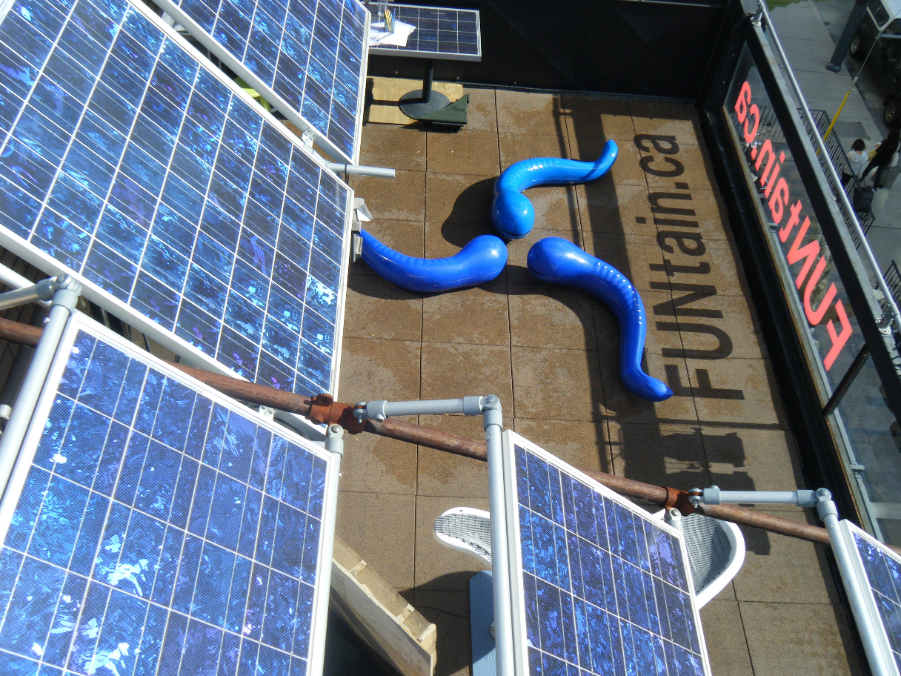

Project Details:

The design would be executed on the roof of Wallberg Building, or the Engineering Annex, or on any other flat roof space such as Sanford Fleming, Bahen Centre, or the like. Prof. Mann has already been in discussion with Professor Elizabeth Edwards about the possibility of constructiong U of T's GreenLab on the roof of Wallberg Building. Prof. Edwards currently has an office on this roof. This effort would be a collaboration between Prof. Edwards, Professor Tim Bender, and various others. Other stakeholders would include Civil Engineering (e.g. Prof. Kim Pressnail), as well as Architecture (We've previously collaborated with Professor Pierre Belanger as well as Larry Wayne Richards when he was Dean of Architecture). A committee comprising myself, Prof. Edwards, and others, would be established to administer the space and review applications for the space usage, in order to ensure that all uses meet applicable safety regulations (e.g. Electrical Safety Authority, TSSA, and the like). Leslie Dolman has also offered to connect us with further industry partners.

Examples of professors with a need for such a space: Prof Greg Evans’ atmospheric research (see http://www.socaar.utoronto.ca/site3.aspx) and Prof. Tim Bender’s research on organic photovoltaics (http://www.chem-eng.utoronto.ca/facultystaff/profs/bender.htm), and Prof. Grant Allen’s research on algae for CO2 sequestration and wastewater treatment (http://www.chem-eng.utoronto.ca/facultystaff/profs/allen.htm) all have need for outdoor research space to really put prototypes to the test.

Potential Users:
Here is a partial list of potential users of the space:

- Chemical Engineering and Applied Chemistry:
-Tim Bender - organic photovoltaics
-Grant Allen - Wastewater and air treatment
-Elizabeth Edwards - Wastewater treatment, biogas production, bioremediation
-Emma Master - Biofuels and bioproducts from biomass
-Greg Evans - Air pollution characterization and mitigation
-Don Kirk - electrochemical and thermal technologies for energy recovery
- Civil Engineering
-Phil Byer - Environmental decision making
-Ron Hoffmann - Water disinfection
-Christopher Kennedy - Green Buildings
-Kim Pressnail - Building Science; Energy conservation

- Mechanical Engineering
-Prof. James S. Wallace – energy studies
- Electrical and Computer Engineering
-Nazir Kherani (joint appoint with Material Science & Engineering) - photovoltaic materials and devices
-Olivier Trescases – energy systems
-Steve Mann – sustainable development, renewable energy, hydraulophonics

- Computer Science
-Khai N. Truong – Autism and Human-Machine interaction (potential hydraulophone user)
-Ron Baecker – Human-Machine interaction (potential hydraulophone user)
-Steve Mann - sustainable development, renewable energy, hydraulophonics

- Architecture
-Larry Richards – curatorial design (potential hydraulophone user)

- Music
-Gage Averill – hydraulophone user
-Charlotte Mundy – vocalist and hydraulist for H2Orchestra (www.h2orchestra.com)

- Geography
-Miriam Diamond - particle and pollutant fate and transport

- Physical Education and Health
-Bruce Kidd (potential hydraulophone user)
- Occupational Therapy
- University Health Network, Toronto General Hospital
-Dr. Alex Jadad (potential hydraulophone user)
- Bloorview Research Inst., Bloorview Kids Rehab
-Jorge Torres-Solis
-Tom Chau

- Theatre
-Pia Kleber - Human Security (collaborations regarding hydraulophone)
-Dario P. Del Degan - Engineering Communications and Theatre (Samuel Beckett, etc.) potential hydraulophone and andantephone user

(Potential users beyond University of Toronto)
- Early Childhood Education (E.C.E.)
-Jason Nolan (Ryerson) - use of hydraulophone for special needs children
- Sheridan
-Interactive Multimedia
-Theatre (already using hydraulophone for theatrical productions about water and sustainability)
- Ryerson University
-Anastasious Venetsanopoulos – Multimedia (potential hydraulophone user)
- Canadian National Institute for the Blind
-Research in outdoor classrooms with emphasis on hydraulophones and sustainable tactile water features
- Hackensack University Medical Center
-Dr. Stephanos Pantagis – use of hydraulophones for geriatrics; research on “urbeaches” and hydraulophones for use in retirement homes

The proposed outdoor GreenLab would be a fantastic addition to BioZone, a new $6M CFI/MRI-funded Centre for Engineering a Sustainable Future, where students from many disciplines work together to solve problems in Environment, Energy and Health. The University of Toronto Pulp and Paper Centre is also co-located with BioZone on the 3rd and 4th floors of the Wallberg building. All of these students would benefit tremendously from having a place to learn and understand about renewable energy and water-saving technologies in a hands-on way. BioZone, led by Professor Elizabeth Edwards, includes a dozen or more professors, a vast array of analytical and molecular biology equipment, and several industry partners, already involves expansion on the West wing of the Wallberg Roof. One possible location for the proposed facility would be on the East wing, providing a contrasting opportunity to traditional laboratory space.

Various experiments and usages would include urban agriculture, photovoltaics, solar thermal, wastewater treatment, irrigation, fluid mechanics, hydraulic sound production (hydraulophonics), wind and weather studies.

Among the elements of this proposal is a student-driven design and project management of a roof mounted solar electric PV installation on campus. The system will be designed to interface with the new Feed In Tariff (FIT) being offered by the Ontario government. As part of the full feasibility report preparation we will be working with the Faculty of Applied Science and Engineering to determine the best rooftop site for the system. The size of the solar array will be 10 kW in order to qualify for the streamlined MicroFIT program. This is approximately three times the size of the prototype (the solar array installed at 330 Dundas Street West). The total cost of the 10kW array might be on the order of $100k, but, given past success at getting donations of this kind of equipment, this cost is likely to be greatly reduced. The electricity generated by the array would be sold back to the grid at the subsidized rate of 80.2 cents/kWh guaranteed for 20 years under the FIT program, which would yield an income of approximately $10,000 per year.

Access to the space would be automatic for all Faculty of Engineering Professors, so that the Faculty of Engineering would feel ownership and responsibility for keeping the space safe and clean. Timed locks would be used to keep the space open during regular business hours, whereas those doing research in the lab could obtain special access permission, as would be the case with any other univeristy lab or teaching facility.

Univeristy of Toronto's GreenLab design would embody three main design elements:

- GreenLab: The GreenLab is an outdoor teaching and research lab space that is partially covered by a retractable greenouse. The retractable greenhouse type of space creates a learning garden. Thus the GreenLab would be partially indoors and partially outdoors, so that a good portion of the space could be used year-round. This space would consist of a patio and meeting space with outdoor classroom that would measure 20 feet by 50 feet (approximately 6 by 15 metres), of which a small portion would have a retractable awning and enclosure (greenhouse), and a similar sized outdoor research lab space also 20 feet by 50 feet (approx. 6 by 15 metres). A 12 by 24 foot (approx. 4 by 7 metres) portion of this patio would be an andantephone (outdoor interactive multimedia surface, http://wearcam.org/andantephone) made of 24 inch (approx. .61 metre) multimedia tiles. These spaces would be arranged so that the entrance faces into the patio and meeting space. The total of the teaching and lab spaces would occupy a 20 by 100 foot (approx. 6 by 30 metres) area of the roof. This split divides the space equally between teaching and research spaces. The research half of this space would make an outdoor lab that would work as a good size multi-function lab having between 16 and 20 workstations with possibly up to 40 worksations. The lab would be used for undergraduate teaching (supervised at all times), as well as graduate research. Phase 2 would see an additional 20 by 50 foot area of the roof devoted to individual experiments that users could setup after approval from the outdoor GreenLab committee. Phase 2 space would be such that individuals, once approved, could setup experiments and leave them running for an extended time period. These might include outdoor photovoltaic arrays, and the like. If the chosen location were the Wallberg Building, then phases 1 and 2 would occupy a 20 by 150 foot (approximately 6 metre by 46 metre) space along the front of the building's roof, directly facing College Street. Phase 3 could see an expansion past a narrow corridor where the natural layout of the roof would facilitate an easy and segregateable secure access to the East portion of the roof, as a separate space used for outdoor lab experiments that are highly sensitive and therefore need to be secured from unauthorized access. Examples might include experiments in UV sterilization of water by sunlight (e.g. where a researcher needs a place to leave bottles of water exposed to natural sun and cloud cover over an entire year or two without disturbance, etc.). Research groups will be able to book secure outdoor space to set up experiments, analytical equipment, and the like to conduct experiments in real-world weather conditions. These might include growth chambers, arrays of organic photovoltaics, and urban agriculture.;

- BlueRoof: The blueroof is a concept created by Mann, in which there is a 2-tier roof arrangement, consisting of an upper roof that supplies water and photovoltaics to a lower roof that houses a garden. A rooftop garden is irrigated by water collected from rainfall that also cools a photovoltaic roof membrane. The roof of Wallberg Building is ideally suited to this kind of construction, where the roof of the mechanical rooms would serve as the upper roof, and its south-facing wall would serve as a “living wall”, connected ecologically to the lower roof. A BlueRoof contains, as part if it, a green roof, which could be formed on the main level rooftop of Wallberg. The upper (mechanical room) roof would be constructed with flexible photovoltaics. The world's first flexible photovoltaic rooftop membrane was installed at 330 Dundas Street West as a prototype. This material would be used at the new location. It creates an aesthetically pleasing roof surface while producing electricity by way of the “plug in your roof” philosophy.

- TeachBeach: The outdoor classroom, outdoor lab, and bookable outdoor secured space all comprise elements of what we call the “TeachBeach”. The rooftop space will become an “urban beach” teaching and research space in which a pleasant outdoor environment is used as an alternative to mechanical refrigeration (air conditioning). This will happen naturally as a side-effect of working outside, e.g. users of the space will experience the increased wellbeing of being outside, in a similar way to a break we might take from work, while walking along a beach. This will reduce the need for mechanical cooling by creating a beachlike atmosophere where people can feel comfortable on warm summer days. The blueroof system also cools the roof membrane and irrigates the greenroof to reduce need for cooling of the interiour. The “TeachBeach” does not require sand, but instead uses the silicon (photovoltaics) as a psychological and aesthetic metaphor for sand. The result is a patio space in which people can relax and do research in a partially outdoor environment. Whether people choose to relax on the patio, or simply pass through this space on their way to the outdoor lab, or secure bookable space, they are reminded of the nice atmosphere that they live in, and the importance of thinking of the environment in all aspects of their research, teaching, and education.

For a published scholarly journal article on these concepts, see “The development of urban renewable energy at the existential technology research center (ETRC) in Toronto, Canada”, by Steve Mann, Isaac Harris, Joshua Harris, in Renewable and Sustainable Energy Reviews, Volume 10, Issue 6, December 2006, Pages 576-589 (accepted November 2004, available online Feb 2005). Download from: www.sciencedirect.com/science/journal/13640321 or http://www.eyetap.org/publications
See also, Comparative Life Cycle Assessment of Standard and Green Roofs by Susana Saiz, Christopher Kennedy, Brad Bass, and Kim Pressnail, Department of Civil Engineering, University of Toronto, 35 St. George Street, Toronto, Ontario, Canada M5S 1A4, in Environ. Sci. Technol., 2006, 40 (13), pp 4312–4316

The GreenLab is inspired, in part, by the outdoor classrooms of poor countries where an enclosed air conditioned space is beyond financial reach but where occupants are often healthier and more in-touch with their environment. The best way to preserve the environment is to appreciate it directly by being in it, rather than removed from it, as we often are in air conditioned spaces. Obviously heat is a necessity in Canada, but an urban beach environment can call into question the necessity of excessive air conditioning. For example, my students were originally housed in an air conditioned windowless lab in Sandford Fleming and complained that it was too cold in the summer. They seldom worked in Sandford Fleming at all in the summer because of the excessive cold. The excessive use of air conditioning is one of the things that led me to create the GreenLab concept.

In the past Mann has had tremendous luck obtaining in-kind donations, and plans to continue to do this in the creation of the GreenLab. One project will be the construction of SolarParasols which will be like umbrellas to shield from the sun but they will be made of solar panels (photovoltaics). This will be a variation on my Solouvre concept already constructed at 330 Dundas.

Additionally, the GreenLab will include plants growing in the year-round greenhouse-like portion of the facility, including studies and experiments in urban agriculture, where we would like to also have a water feature. The water feature would be a passive maintenance-free hydraulophone donated by FUNtain Corporation which will be used in research on fluid dynamics, fluid flow, Karman vortex shedding, and heat transfer in fluids. Hydraulophones have already been sucessfully used in classroom settings. We (FUNtain Corp) sold one to CNIB (Canadian National Institute for the Blind) for their outdoor classroom, as well as one to Mayborn Museum for indoor use, and one to the Chicago Children's Museum for classroom use. These water features make good teaching installalations as well as provide for recreational use in a way that eliminates the risks assocated with water features (e.g. standing water is eliminated, etc.). The hydraulophone is a proven teaching tool, having established itself as being safe, environmentally friendly, maintenance free, and useful for both teaching and research.

Above: Outdoor Classroom at CNIB headquarters in Calgary.

The hydraulophone will function as a musical irrigation system, as well as a musical humidifier that combines art, science, and technology with form and function. This water feature will be incorporated into a “living wall” similar to the living wall on the second floor of Galbraith Building. This feature will aslo be used for interdisciplinary collaboration, including the continuation of ongoing collaborations with the Faculty of Music as well as Occupational Therapy, Physical Education and Health, etc. (other users of this water feature). Collaborations already initiated with Bruce Kidd, Dean, Faculty of Physical Education and Health, Ethnomusicologist Gage Averill, since when he was Dean of University of Toronto's Faculty of Music, and many others across University of Toronto's campus. For more information on hydraulophone, see http://wearcam.org/watershapes/index.htm

Examples of concepts to be explored:

The concepts to be brought into the proposed space will not only save money but will also engender a philosophy of conservation by serving as a means to educate the University of Toronto population about energy conservation. One concept deployed in the prototype facility was the creation of a Universal Connector (UC) for electrical energy management. UC is to buildings what USB is to computer equipment. UC is a radially symmetric Class 2 connector installed in every room in the building, for plugging in small computers and other low power devices without the need for a separate power converter that wastes energy. UC operates at 12 volts and 5 Amperes so that it falls within the Class 2 designation of the Electrical Safety Authority (ESA). In this way, safety and energy conservation are both promoted and increased, by eliminating the “rats nests” of wires and transformers that “grow” around a mess of extension cords on various floors.

UC is directly powered by wind, solar, and off-grid supplies as well as centralized transformers that operate more efficiently. The UC breaker panels operate at 12 volts DC and each breaker is 5A rather than 15A typically found in previous breaker panels. This helps to promote energy conservation.

Additionally, the “TeachBeach” philosophy helps encourage a lifestyle that relies less on mechanical refrigeration (air conditioning) and more on being in harmony with nature. Consider, for example, the energy that might be saved if we did not refrigerate offices below standard room temperature (many offices are currently refrigerated even below the standard comfortable temperature of 21-25 deg. C and are too cold for people wearing normal summer clothes).

Previously, we have had a large number of visitors to our prototype facility at 330 Dundas, including Jack Layton and Olivia Chow who visit regularly (Olivia Chow published a calendar in which three of photographs from the 12 in the calendar depicted installations that were created by the applicant). Clearly there is already a tremendous support for this project in the City of Toronto and in Ottawa. This support will be very helpful in making the project a success in its own right, as well as a success as a role model for other rooftops.

Possible location: roof of Wallberg Building...
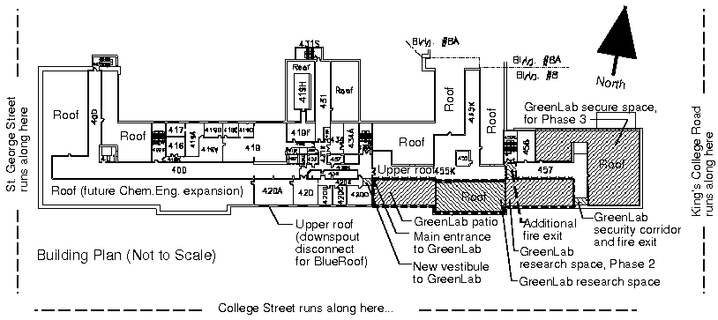

Estimated project cost
Can$150,000 of which $75,000 would be from matching and $75,000 from this grant; additional aspects of project to be covered by in-kind donations.
Estimated annual operation & maintenance cost
$0.00
Projected timeline for completion of project
Summer 2012

Project Benefits:
a) Expected utilities savings from the project, and estimated associated financial savings. Please see FAQ section at http://sustainability.utoronto.ca/projects/fund.htm for standard utility rates. Note that savings can be estimates at this stage of the process; savings can be better quantified during stage 2 of the application process.

Electricity savings ($/year): $9515 (FIT program credit) + $6000 (reduction in AC)
Thermal energy savings (BTU or m³ of natural gas/year): $2000 ($1000 in solar vacuum tubes and $1000 in fumehood heat recovery)
Water saving ($/year): $1500
Financial savings ($/year): $19015

b) Additional project benefits such as visibility, deferred maintenance and staff/student engagement
The intention is to create a practical teaching environment to be used for regular electrical engineering courses. This lab, however, will be auto-sufficient by utilizing solar and aeolic energy, as well as water from the rain. In addition to the technical aspect of its sustainability, it will also promote a healthier learning environment by allowing increased exposure to daily sunlight, as well as a more pleasant environment with the presence of water features. The water features will be donated by FUNtain Corporation, a Canadian company formed by Mann and one of his former students. The GreenLab will be visible on the roof of Wallberg (or the Engineering Annex Building or whatever other building it would be placed on). If placed on the roof of Wallberg, the community will see from College street Univeristy of Toronto's great facility and how U of T is doing its best to promote sustainability, and the Phase 3 portion of the facility will also overlook (and be visible from) King's College. This facility on Wallberg would be strategically placed to visually and artistically respond to both main entrances to the University. It will operate with 12 volt DC outlets ideal for portable, battery operated devices and development circuitry -- fed by solar panels which will also serve to charge batteries for other devices used in the lab. Rain water will be collected, stored and utilized in the water features, in cleaning/maintenance and as toilet flushing water. This lab will follow an award-winning model already created and implemented in prototype form by Dr. Steve Mann.

This project will bring international acclaim to University of Toronto as innovators in sustainability.

It will also bring other indirect savings, as the philosophy that it engenders spreads throughout the rest of the university.

For the Faculty the project could be used as a demonstration for electrical and sustainable engineering courses, and will generate a revenue stream and have a good ROI based on participation in the FIT program.

For the students involved it will be a great opportunity to be involved in renewable energy projects, which is an industry that is anticipated to have huge growth in the coming years partly because of the new subsidies.

Is the space identified in the proposed project currently part of the Division's allocation?
Yes If not, please explain:
No It is an extension to the existing allocation.

Has the Division applied for and/or acquired funds from any other sources—either internal or external—to fund this project?
Yes If yes, please explain:
No

B | Final Authorization and Submissions to the Sustainability Fund Committee  (to be completed by Principal, Dean, Chief Librarian, or Vice-President)
Source of faculty funds for this project:
Amount: $75,000 CFC/Fund: CC/IO:
I have reviewed the above request and have confirmed that the proposal is consistent with divisional and/or departmental plans:
 | Name:  Signature:  Date: |  | Position:  Dean  Designate

If you have any questions, or to submit completed forms, please contact Luke Raftis:
t: 416.978.6792
f: 416.978.3884
e: luke.raftis@utoronto.ca
University of Toronto Sustainability Office
South Borden Building, Suite 208
487 Spadina Crescent
http://sustainability.utoronto.ca/about/contact.htm

